AI-Based Smart Waste Segregation and Recycling Automation System
Agile Sprint Planning & User Story Workshop

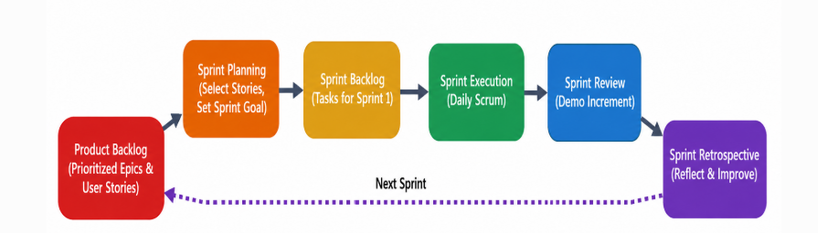

The Scrum framework applied to this project's development lifecycle
Domains: Artificial Intelligence | Computer Vision | Robotics | IoT | Agile Software Engineering

1. Project Vision and Stakeholders

1.1 Project Vision

The vision of the AI-Based Smart Waste Segregation and Recycling Automation System is to develop an intelligent, automated, and sustainable waste management platform that improves the efficiency of waste segregation using Artificial Intelligence (AI), Computer Vision, Robotics, and Internet of Things (IoT) technologies.

The proposed system replaces conventional manual waste sorting with an automated process capable of identifying, classifying, and separating different categories of waste in real time. Using high-resolution cameras and deep learning algorithms, the system detects materials such as plastic, paper, glass, metal, and organic waste with high accuracy. Robotic arms then automatically place each waste item into the appropriate recycling container.

IoT sensors continuously monitor bin levels, equipment status, and waste collection data, while a centralized cloud dashboard provides real-time analytics, performance reports, and recycling statistics for municipal authorities.

The project aims to support Smart City initiatives by reducing landfill waste, improving recycling rates, minimizing operational costs, and promoting environmental sustainability. Ultimately, the platform contributes to the Circular Economy, where valuable materials are recovered, reused, and recycled instead of being discarded.

1.2 Key Stakeholders
Stakeholder | Role / Interest | Primary Concern
Municipal Waste Management Authority | Product Owner / Client sponsor | Recycling rate improvement, ROI
Facility Operators & Sorting Staff | End users of the system on the floor | Ease of use, safety, reliability
Scrum Development Team | AI, robotics, IoT, and software engineers | Clear requirements, feasible sprints
Environmental Compliance Officers | Regulatory oversight | Accurate reporting, pollution reduction
Recycling Partner Companies | Downstream material buyers | Material purity, consistent volumes
IoT / Hardware Vendors | Sensor and robotic arm suppliers | Integration compatibility
Residents / Citizens | Indirect beneficiaries | Cleaner environment, lower costs

1.3 Stakeholder Responsibilities

Municipal Waste Management Authority

The Municipal Waste Management Authority acts as the primary project sponsor and decision-maker. It is responsible for approving project funding, defining the overall system requirements, and ensuring that the proposed solution aligns with municipal waste management objectives. The authority continuously monitors project performance, reviews waste management reports generated by the system, and ensures the successful implementation of the AI-based waste segregation platform across waste processing facilities.

Facility Operators

Facility operators are responsible for the day-to-day operation of the waste segregation system. They monitor the conveyor belt, robotic sorting mechanisms, and overall plant operations to ensure smooth functioning. They also respond to maintenance alerts, report system issues to the technical team, and ensure that waste is processed safely and efficiently with minimal operational interruptions.

Development Team

The development team is responsible for designing, developing, testing, and maintaining the entire AI-based waste segregation system. They build the AI model for waste classification, develop the IoT platform for real-time monitoring, and create the dashboard for analytics and reporting. In addition, the team integrates hardware components such as cameras, sensors, and robotic arms with the software system and performs regular testing, deployment, and maintenance to ensure reliable system performance.

Environmental Compliance Officers

Environmental Compliance Officers ensure that the waste management system follows all environmental regulations and government policies. They monitor pollution reduction efforts, verify that waste disposal practices meet regulatory standards, review environmental performance reports, and encourage sustainable waste management practices to minimize environmental impact.

Recycling Partner Companies

Recycling partner companies play a vital role in processing the segregated recyclable materials. They collect recyclable waste from the facility, ensure the quality and purity of materials, process them into reusable resources, and support resource recovery initiatives. Their collaboration helps improve recycling efficiency and promotes the circular economy by reducing the amount of waste sent to landfills.

IoT and Hardware Vendors

IoT and hardware vendors provide the essential equipment required for the system, including sensors, cameras, conveyor components, and robotic arms. They are responsible for installing the hardware, ensuring seamless integration with the software platform, providing technical support whenever required, and performing regular maintenance to keep the equipment functioning efficiently and reliably.

2. Epics and User Stories
The product backlog is organized into five Epics, each representing a major functional area of the system. Every Epic is broken down into concrete User Stories written in the standard Agile format: "As a <user>, I want <feature>, so that <benefit>."

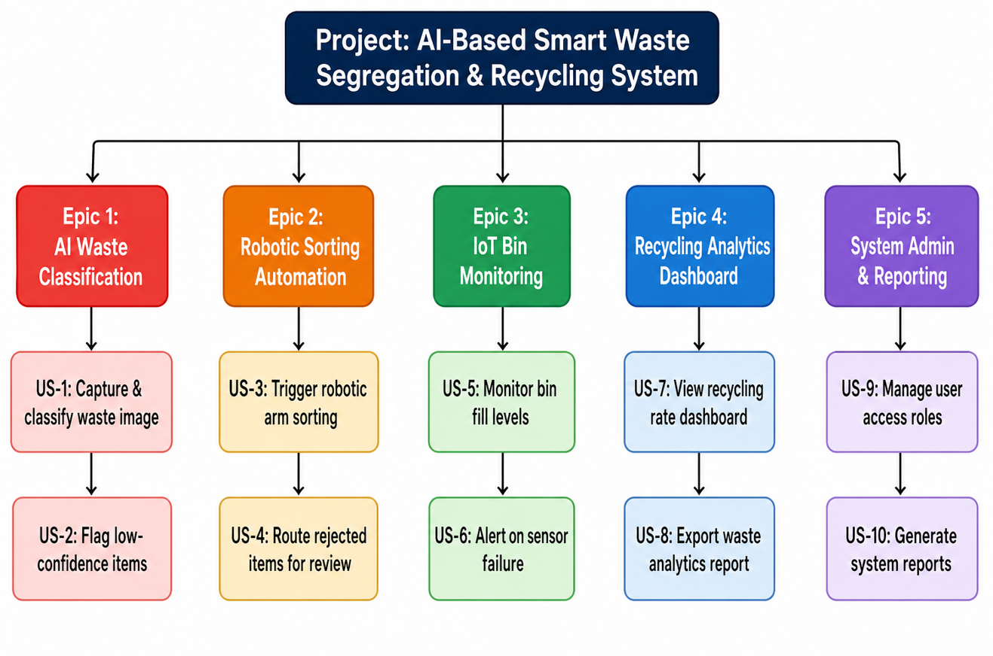
Figure 1: Breakdown of the product into Epics and User Stories

Epic 1 – AI Waste Classification
- US-1: As a facility operator, I want the system to capture and classify each waste item's image in real time, so that items are correctly identified before sorting.
- US-2: As a facility operator, I want low-confidence classifications flagged for manual review, so that misclassified items don't contaminate recycling streams.

Epic 2 – Robotic Sorting Automation
- US-3: As a facility operator, I want a robotic arm to automatically sort classified items into the correct bin, so that manual sorting labor is minimized.
- US-4: As a facility operator, I want flagged/rejected items routed to a manual review queue, so that sorting accuracy is preserved.

Epic 3 – IoT Bin Monitoring
- US-5: As a facility manager, I want real-time bin fill-level monitoring, so that collection can be scheduled before bins overflow.
- US-6: As a maintenance engineer, I want alerts when a sensor or robotic arm fails, so that downtime is minimized.

Epic 4 – Recycling Analytics Dashboard
- US-7: As a facility manager, I want a live dashboard of recycling rates and waste composition, so that I can track performance against targets.
- US-8: As a compliance officer, I want to export waste management reports, so that I can demonstrate regulatory compliance.

Epic 5 – System Administration & Reporting
- US-9: As a system administrator, I want to manage user roles and access permissions, so that only authorized staff can change system configuration.

3. Acceptance Criteria
Acceptance Criteria define the conditions that must be satisfied for a User Story to be considered complete and accepted by the Product Owner. They help ensure that every feature functions correctly, meets stakeholder requirements, and is testable. For the AI-Based Smart Waste Segregation and Recycling Automation System, the acceptance criteria are written using the Given–When–Then format.
Story ID | User Story (Short Title) | Acceptance Criteria (Given–When–Then Format)
US-1 | Capture and Classify Waste Image | Given a waste item is placed on the conveyor belt, When the camera captures its image, Then the system shall classify the waste into the correct category (Plastic, Paper, Metal, Glass, Organic, or Others) with at least 90% accuracy and display the predicted result within 500 milliseconds.
US-2 | Handle Low-Confidence Classification | Given the AI confidence score is below 85%, When the waste item reaches the sorting point, Then the system shall automatically divert it to the manual inspection area, generate an alert, and record the event for future analysis.
US-3 | Robotic Waste Sorting | Given a waste item has been classified with a confidence score of 85% or above, When it reaches the robotic arm, Then the robotic arm shall pick the waste and place it into the correct labeled recycling bin within 2 seconds with a success rate of at least 95%.
US-4 | Real-Time IoT Monitoring | Given IoT sensors are active, When the waste segregation system is operating, Then the system shall continuously monitor bin level, weight, and sensor status, and update the dashboard every 10 seconds.
US-5 | Smart Bin Full Alert | Given a waste bin reaches 90% capacity, When the threshold is exceeded, Then the system shall automatically send an alert notification to the facility operator through the dashboard and email/SMS within 1 minute.
US-6 | Maintenance Alert Generation | Given any hardware component (camera, robotic arm, or IoT sensor) fails or becomes unresponsive, When the fault is detected, Then the system shall generate a maintenance alert with error details and notify the maintenance team immediately.
US-7 | Dashboard Analytics View | Given waste processing data is available, When the manager opens the dashboard, Then the system shall display real-time recycling statistics, waste category distribution, landfill reduction percentage, total waste processed, and performance charts updated every hour.
US-8 | Export Waste Reports | Given the manager selects a report type and date range, When the export option is clicked, Then the system shall generate and download the report in PDF or Excel format within 30 seconds.
US-9 | User Role Management | Given an administrator is logged into the system, When user accounts or roles are created, updated, or deleted, Then the system shall immediately apply the changes and prevent unauthorized access to restricted features.
US-10 | Automatic Data Backup | Given the cloud database is active, When the scheduled backup time is reached, Then the system shall automatically back up all waste management data, store it securely in the cloud, and maintain backup logs for future recovery.

4. Product Backlog Prioritization
The backlog is prioritized using a combination of business value and MoSCoW classification, reflecting what is essential for a functioning first release versus what can follow in later sprints.
The Product Backlog is a prioritized list of all user stories required to develop the AI-Based Smart Waste Segregation and Recycling Automation System. Prioritization ensures that the Scrum Team focuses first on features that deliver the highest business value and are essential for the successful operation of the system.
For this project, the backlog is prioritized using the MoSCoW technique, which classifies requirements into four categories:
- Must Have – Essential features required for the first release.
- Should Have – Important features that improve system performance but can be implemented after the core functionalities.
- Could Have – Optional features that provide additional value if time and resources permit.
- Won't Have (This Release) – Features planned for future releases but not included in the current sprint.
This prioritization helps the development team allocate resources effectively, manage sprint planning efficiently, and deliver a functional product within the project timeline.

Story | Title | Business Value | MoSCoW | Rank
US-1 | AI image capture & classification | High | Must Have | 1
US-3 | Robotic arm sorting | High | Must Have | 2
US-2 | Low-confidence flagging | High | Must Have | 3
US-4 | Manual review routing | Medium | Should Have | 4
US-5 | Bin fill-level monitoring | Medium | Should Have | 5
US-7 | Recycling analytics dashboard | Medium | Should Have | 6
US-6 | Sensor/robot failure alerts | Low | Could Have | 7
US-8 | Exportable compliance reports | Low | Could Have | 8
US-9 | User role administration | Low | Won't Have (this release) | 9

5. Sprint Backlog Plan (Sprint 1)
Sprint 1 is a two-week sprint focused on delivering the core detection-to-sorting pipeline. The top four ranked stories (US-1, US-3, US-2, US-4) are pulled into the sprint backlog and broken down into actionable development tasks.
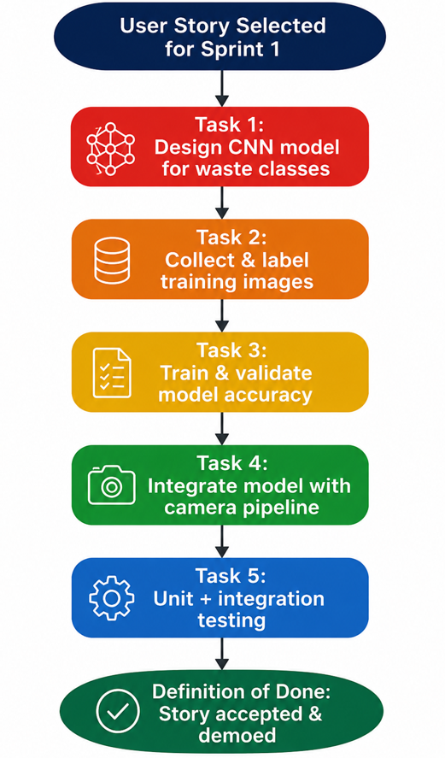
Figure 2: Task breakdown for US-1 (AI image capture & classification) within Sprint 1

Sprint 1 Task Breakdown Summary
Story | Tasks
US-1 | Design CNN model; collect & label training images; train and validate accuracy; integrate model with camera pipeline; unit and integration testing.
US-3 | Select robotic arm actuator; write arm-control API; integrate with classification output; calibrate sorting positions; test end-to-end sorting cycle.
US-2 | Define confidence threshold; build review-queue data structure; implement routing logic; create simple review UI mock; test edge cases.
US-4 | Implement conveyor diversion mechanism; link to review queue; log diverted items; test with contaminated/overlapping items.
-
6. Story Point Estimation

Story points are assigned using Planning Poker with the Fibonacci sequence (1, 2, 3, 5, 8, 13), reflecting relative effort and complexity rather than absolute time. The team converged on the following estimates after discussion of technical risk and dependencies.
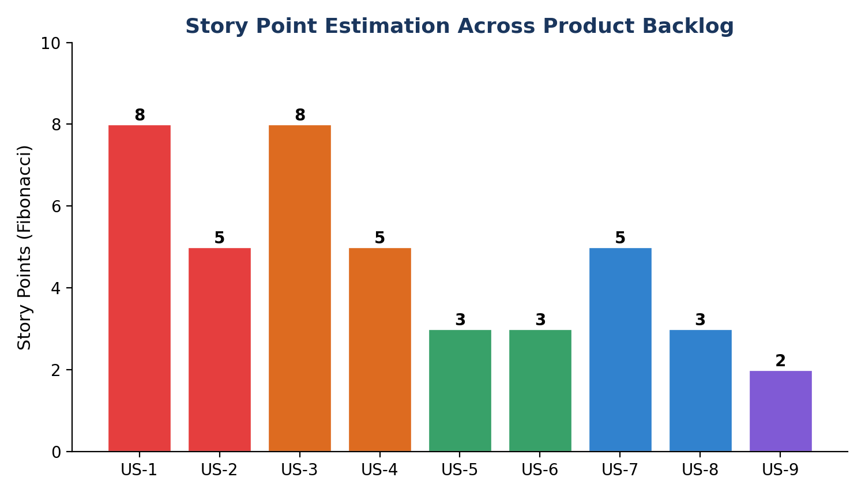
Figure 3: Story point distribution across the product backlog
Story | Justification | Points
US-1 | Requires model design, dataset labeling, and training — high complexity and uncertainty. | 8
US-3 | Hardware integration with new robotic actuator; calibration risk is high. | 8
US-2 | Threshold logic is simple, but the review queue and UI add moderate scope. | 5
US-4 | Builds directly on existing conveyor and queue components from US-2. | 5
US-5 | Standard IoT sensor integration with well-understood patterns. | 3
US-6 | Alerting logic on top of existing sensor data pipeline. | 3
US-7 | Dashboard UI with charts consuming an already-defined analytics API. | 5
US-8 | Export function reusing dashboard's existing data queries. | 3
US-9 | Simple role-based access control using standard framework features. | 2

7. Sprint Goal and Expected Deliverables

7.1 Sprint Goal
"By the end of Sprint 1, deliver a working end-to-end pipeline that captures an image of a waste item, classifies it using the AI model, and automatically sorts high-confidence items via the robotic arm — while routing low-confidence items to a manual review queue."

7.2 Expected Sprint Deliverables
- A trained and integrated CNN classification model achieving at least 85% accuracy on the validation dataset.
- A functioning robotic arm control module that sorts classified items into the correct bin within 2 seconds.
- A confidence-based routing mechanism that diverts uncertain classifications to a manual review queue.
- Automated test coverage for the classification-to-sorting pipeline, including edge cases such as overlapping or contaminated items.
- A short sprint review demo showing the pipeline sorting a live batch of mixed sample waste items.
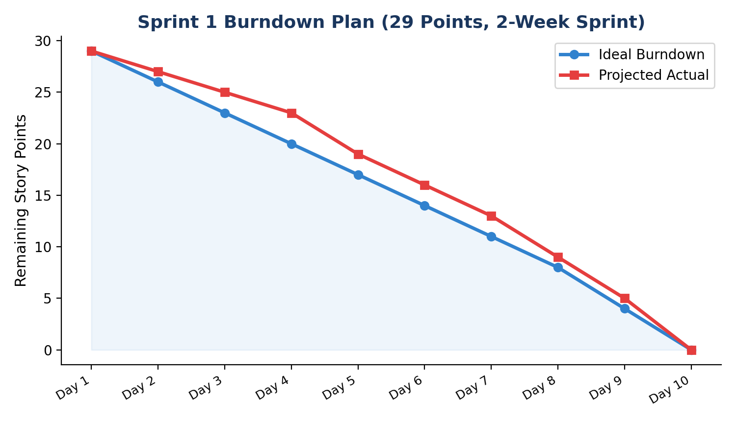
Figure 4: Planned Sprint 1 burndown for the 29 committed story points
This sprint sets the technical foundation — automated classification and physical sorting — that later sprints will build upon by adding IoT monitoring, the analytics dashboard, and administrative reporting features from the remaining backlog.

